**HOME**  **OUR WORK** **ABOUT**  **BLOG**   **CONTACT**

**Sliding images**

**What We Stand For**

"What we stand for" can refer to a variety of things,

including an individual's core values,

a company's or organization's principles,

or the message of a song or album.

It essentially means what principles or beliefs a person, group,

or entity supports and advocates for.

**Bootstrap**

Our Vision

Objectives

Our Core Values

Our Mission

**Every day, together with you, Mthombo’ Ngashi saves lives and helps millions of people find the way to a better life** **worldwide.**

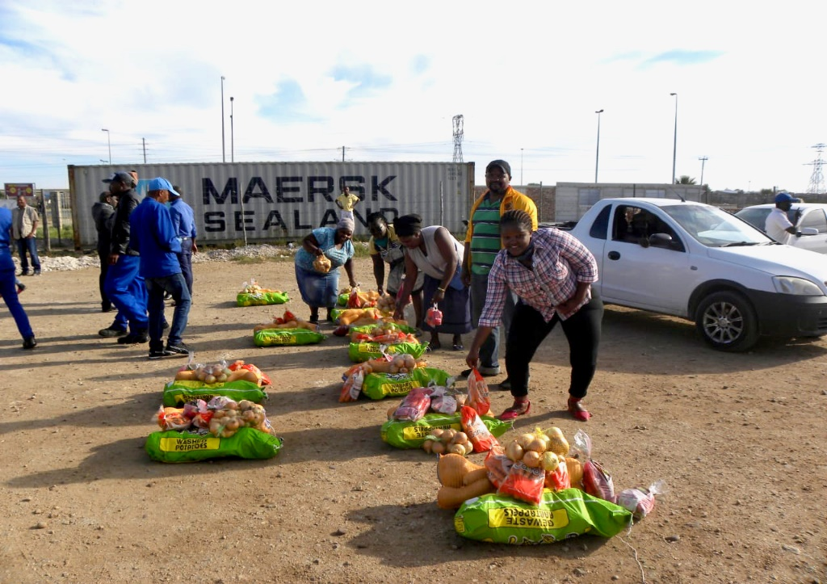

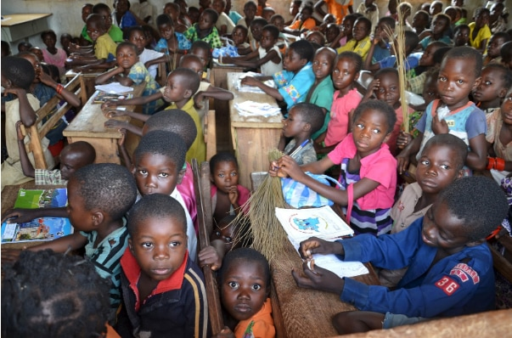

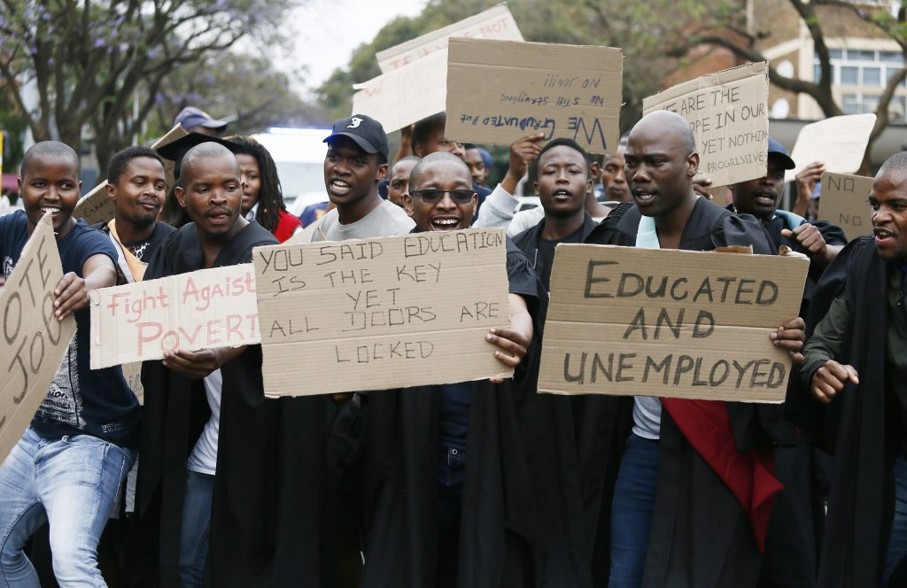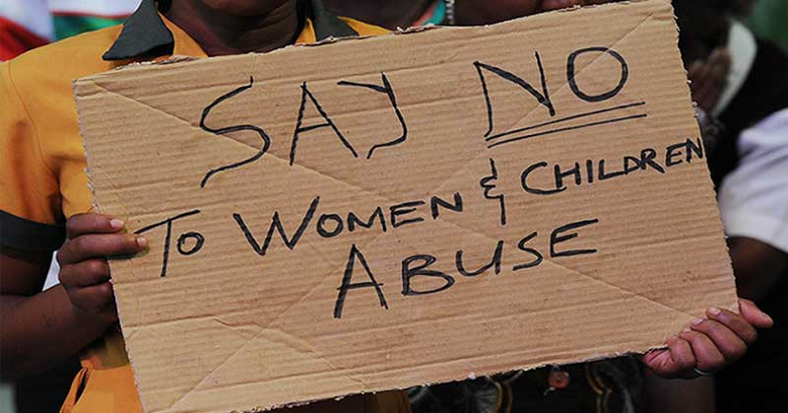



We end poverty by focusing on hunger, health, education, and equality, daily and in times of crisis.

**Help End Hunger Today**

**Volunteer**

**Give your time and serve your community.**

Get Started

**Fundraise**

Start a fundraiser and inspire others to give.

**Learn More**

**Give Monthly**

Join our Hunger Council with a monthly gift

**Donate Now**

**Give Today**

$1 can help provide 10 meals!

Donate Now

**Make a Difference**

Help protect America's priceless natural

landscapes and ensure that we

have healthy environments,

places to work and play, and real economic opportunity.



|  |  |  |  |
| --- | --- | --- | --- |
| Thank you for visiting campaign website. We're committed to transparency, inclusivity & making difference in our community Your support and engagement are vital. | **Quick Links**  [Home](https://html.vikinglab.agency/politico/)  [Service](https://html.vikinglab.agency/politico/)  [About Us](https://html.vikinglab.agency/politico/)  [Latest News](https://html.vikinglab.agency/politico/)  [Contact Us](https://html.vikinglab.agency/politico/) | **Quick Links**  Privacy Policy  Team & Conditions  Support  FAQ  Election | Call Or Message  [**123-456-7890**](tel:1234567890)  Email Address:  [**info@gmail.com**](mailto:info@gmail.com) |

**OUR WORK (INSIDE THE IMAGE) (NEW PAGE)**

**A Solid Track Record**

**Based on more than ten years of experience working in one of the world’s most ungoverned and challenging regions, we have developed and refined a widely respected approach that focuses on the protection of vulnerable communities from violence and exploitation, elevates local solutions, and adapt in volatile and unpredictable environments.**

**The Gameplan**

**What needs to happen?**

A safe and thriving central Africa is possible. Communities themselves hold the keys to achieving that goal. Our role is to listen, follow their lead, and bring the expertise and ingenuity that best complements theirs.

1 of 3

EQUIP THE MOST VULNERABLE COMMUNITIES WITH BASIC RESILIENCE

We will work with the region’s most severely isolated and vulnerable communities to ensure that they are well equipped to recover from the impact of violence and break cycles of future violence. Together, we will identify each community’s unique strengths and local wisdom, and we will complement that with additional support that will enable them to better organize, foster unity, mediate conflict, heal from trauma, and plan for a hopeful future.

1 of 3

END THE EXTREME ISOLATION THAT ENABLES VIOLENCE

We will build, expand, and improve local communication systems to ensure that every community in central Africa has access to lifesaving information and the ability to call for help when threatened with violence. We will train communities to collect and share security information and will organize regular forums for collaboration between local and international experts to develop the most effective solutions to violence and exploitation.

**Keep on keeping’ on**

Your donations make our work possible. Because of you, our work can continue.



|  |  |  |  |
| --- | --- | --- | --- |
| Thank you for visiting campaign website. We're committed to transparency, inclusivity & making difference in our community Your support and engagement are vital. | **Quick Links**  [Home](https://html.vikinglab.agency/politico/)  [Service](https://html.vikinglab.agency/politico/)  [About Us](https://html.vikinglab.agency/politico/)  [Latest News](https://html.vikinglab.agency/politico/)  [Contact Us](https://html.vikinglab.agency/politico/) | **Quick Links**  Privacy Policy  Team & Conditions  Support  FAQ  Election | Call Or Message  [**123-456-7890**](tel:1234567890)  Email Address:  [**info@gmail.com**](mailto:info@gmail.com) |

OUR BLOG (Update and Inspiration) **(NEW PAGE)**

|  |  |
| --- | --- |
| Profile Random Person Round Photos ...  February 29, 2024  by Bridgette Bugay | **Mobile Cinema & Peacebuilding in CAR // USAID’s People-to-People Activity**  In 2021, Invisible Children partnered with the United States Agency for International Development (USAID) to implement USAID’s People to People (P2P) Activity in the Central African Republic (CAR), a multi-year initiative that equips Central African youth peacebuilders with the skills needed to reduce intercommunal tension and armed group violence in eastern CAR. A key component […] |
| Profile Random Person Round Photos ...  **February 29, 2024**  **by Bridgette Bugay** | **Mobile Cinema & Peacebuilding in CAR // USAID’s People-to-People Activity**  In 2021, Invisible Children partnered with the United States Agency for International Development (USAID) to implement USAID’s People to People (P2P) Activity in the Central African Republic (CAR), a multi-year initiative that equips Central African youth peacebuilders with the skills needed to reduce intercommunal tension and armed group violence in eastern CAR. A key component […] |
| Profile Random Person Round Photos ...  **February 29, 2024**  **by Bridgette Bugay** | **Mobile Cinema & Peacebuilding in CAR // USAID’s People-to-People Activity**  In 2021, Invisible Children partnered with the United States Agency for International Development (USAID) to implement USAID’s People to People (P2P) Activity in the Central African Republic (CAR), a multi-year initiative that equips Central African youth peacebuilders with the skills needed to reduce intercommunal tension and armed group violence in eastern CAR. A key component […] |
| Profile Random Person Round Photos ...  **February 29, 2024**  **by Bridgette Bugay** | **Mobile Cinema & Peacebuilding in CAR // USAID’s People-to-People Activity**  In 2021, Invisible Children partnered with the United States Agency for International Development (USAID) to implement USAID’s People to People (P2P) Activity in the Central African Republic (CAR), a multi-year initiative that equips Central African youth peacebuilders with the skills needed to reduce intercommunal tension and armed group violence in eastern CAR. A key component […] |
| Profile Random Person Round Photos ...  **February 29, 2024**  **by Bridgette Bugay** | **Mobile Cinema & Peacebuilding in CAR // USAID’s People-to-People Activity**  In 2021, Invisible Children partnered with the United States Agency for International Development (USAID) to implement USAID’s People to People (P2P) Activity in the Central African Republic (CAR), a multi-year initiative that equips Central African youth peacebuilders with the skills needed to reduce intercommunal tension and armed group violence in eastern CAR. A key component […] |

|  |  |  |  |
| --- | --- | --- | --- |
| Thank you for visiting campaign website. We're committed to transparency, inclusivity & making difference in our community Your support and engagement are vital. | **Quick Links**  [Home](https://html.vikinglab.agency/politico/)  [Service](https://html.vikinglab.agency/politico/)  [About Us](https://html.vikinglab.agency/politico/)  [Latest News](https://html.vikinglab.agency/politico/)  [Contact Us](https://html.vikinglab.agency/politico/) | **Quick Links**  Privacy Policy  Team & Conditions  Support  FAQ  Election | Call Or Message  [**123-456-7890**](tel:1234567890)  Email Address:  [**info@gmail.com**](mailto:info@gmail.com) |

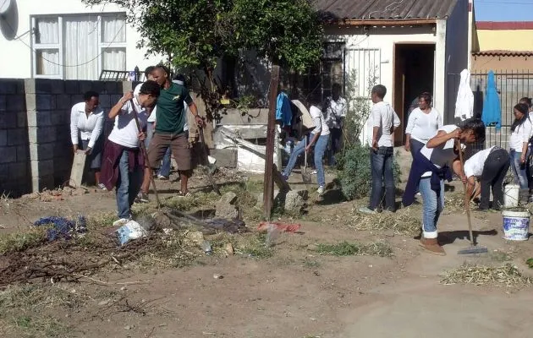**ABOUT (NEW PAGE)**

**ABOUT US**

"What we stand for" can refer to a variety of things,

including an individual's core values,

a company's or organization's principles,

or the message of a song or album.

It essentially means what principles or beliefs a person, group,

or entity supports and advocates for.

**Bootstrap**

Our Vision

Objectives

Our Core Values

Our Mission

|  |  |  |  |
| --- | --- | --- | --- |
| Thank you for visiting campaign website. We're committed to transparency, inclusivity & making difference in our community Your support and engagement are vital. | **Quick Links**  [Home](https://html.vikinglab.agency/politico/)  [Service](https://html.vikinglab.agency/politico/)  [About Us](https://html.vikinglab.agency/politico/)  [Latest News](https://html.vikinglab.agency/politico/)  [Contact Us](https://html.vikinglab.agency/politico/) | **Quick Links**  Privacy Policy  Team & Conditions  Support  FAQ  Election | Call Or Message  [**123-456-7890**](tel:1234567890)  Email Address:  [**info@gmail.com**](mailto:info@gmail.com) |

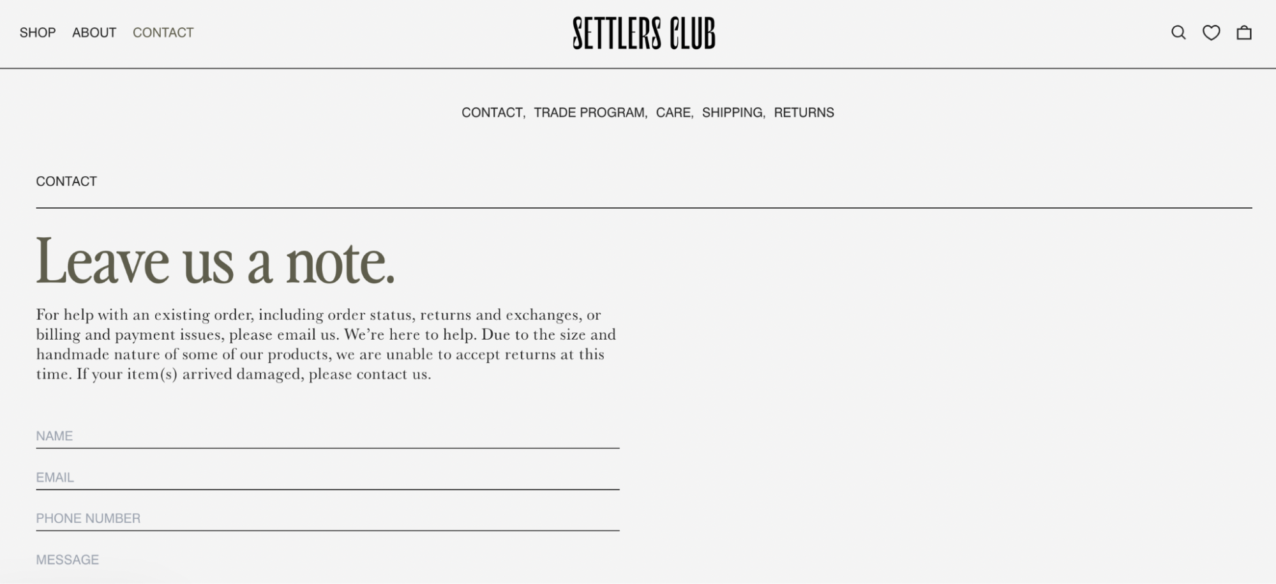

|  |  |  |  |
| --- | --- | --- | --- |
| Thank you for visiting campaign website. We're committed to transparency, inclusivity & making difference in our community Your support and engagement are vital. | **Quick Links**  [Home](https://html.vikinglab.agency/politico/)  [Service](https://html.vikinglab.agency/politico/)  [About Us](https://html.vikinglab.agency/politico/)  [Latest News](https://html.vikinglab.agency/politico/)  [Contact Us](https://html.vikinglab.agency/politico/) | **Quick Links**  Privacy Policy  Team & Conditions  Support  FAQ  Election | Call Or Message  [**123-456-7890**](tel:1234567890)  Email Address:  [**info@gmail.com**](mailto:info@gmail.com) |

**DONATE TODAY (New Page)**

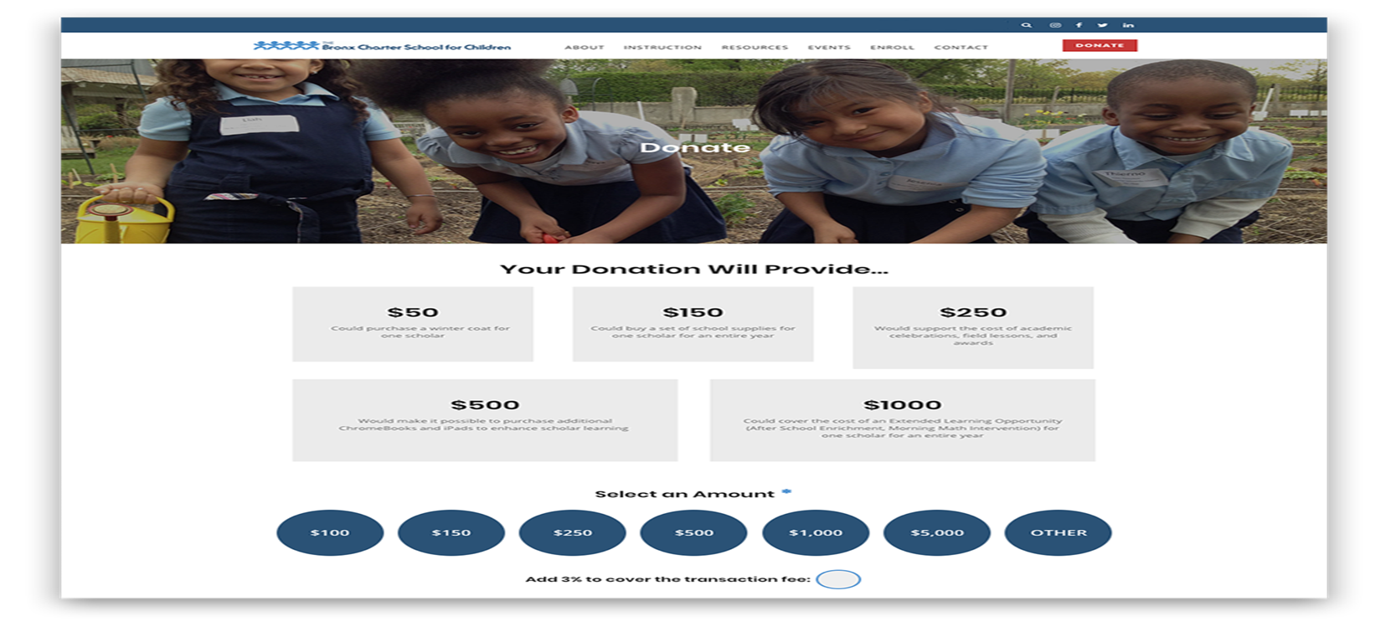

|  |  |  |  |
| --- | --- | --- | --- |
| Thank you for visiting campaign website. We're committed to transparency, inclusivity & making difference in our community Your support and engagement are vital. | **Quick Links**  [Home](https://html.vikinglab.agency/politico/)  [Service](https://html.vikinglab.agency/politico/)  [About Us](https://html.vikinglab.agency/politico/)  [Latest News](https://html.vikinglab.agency/politico/)  [Contact Us](https://html.vikinglab.agency/politico/) | **Quick Links**  Privacy Policy  Team & Conditions  Support  FAQ  Election | Call Or Message  [**123-456-7890**](tel:1234567890)  Email Address:  [**info@gmail.com**](mailto:info@gmail.com) |